IntColl4 Test Screens:

1. The test data creates a collection test of size 3.
2. Inserts 4 numbers into test.
3. Prints the collection.
4. Inserts another number to the collection, and prints the updated collection.
5. Omits a number from the collection, and prints the updated collection.
6. Creates a new collection test 2, and copies the values of test, and prints the copy.
7. A new value is then inserted into test2.
8. The collections and then checked to see if they are equal.
9. The new value is then checked to see if it belongs in test2.

Test ints:

int t1 = 84;

int t2 = 0;

int t3 = 5;

int t4 = 53;

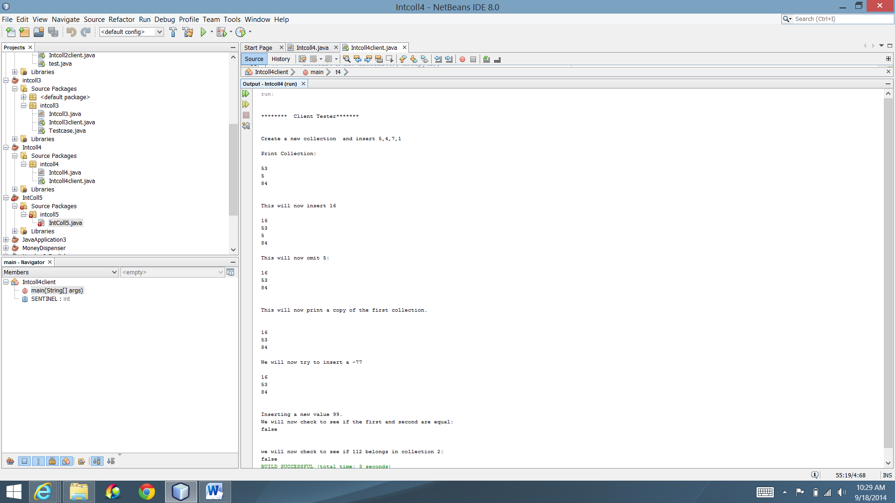

Test 2:

int t1 = -15;

int t2 = 99;

int t3 = 800;

int t4 = 67;

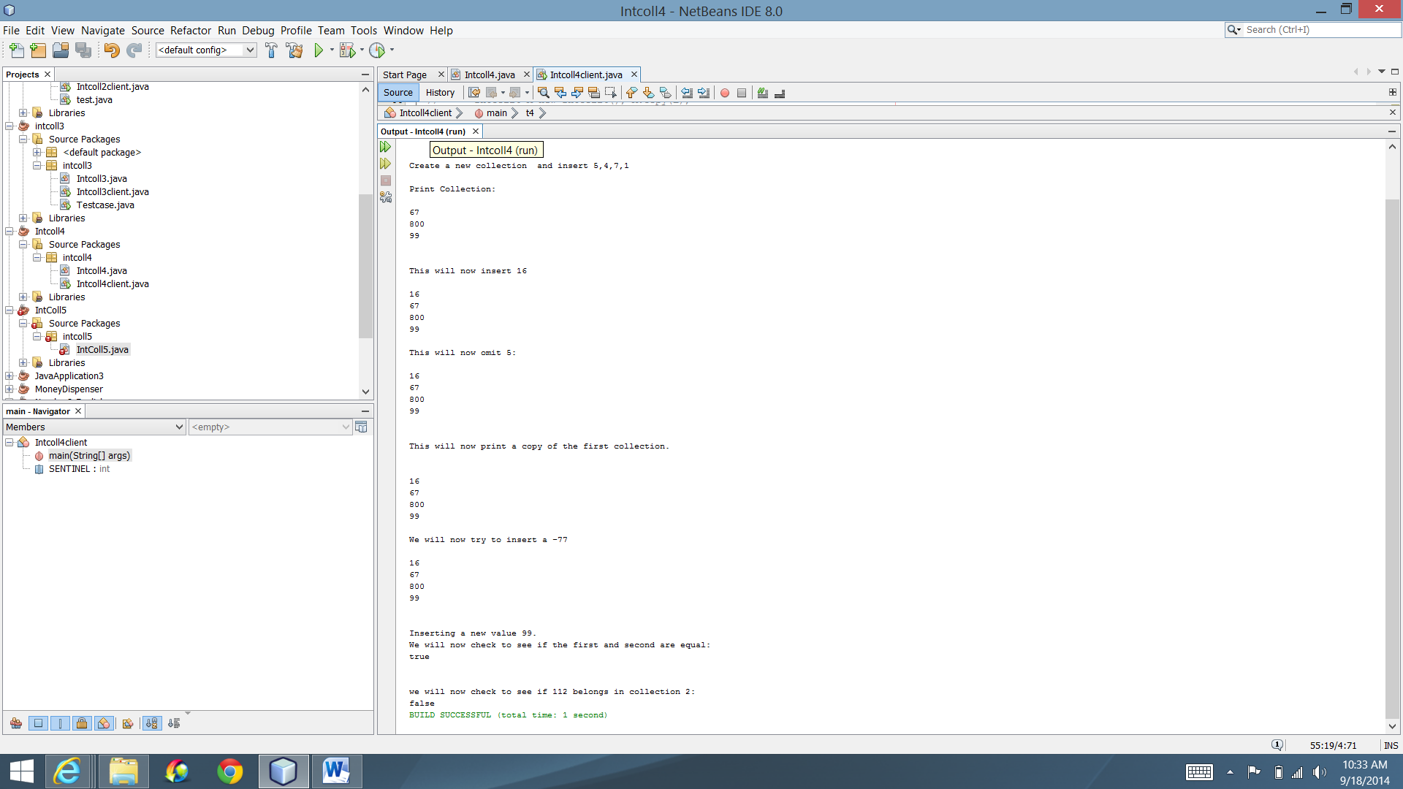

Test 3:

int t1 = -100;

int t2 =0;

int t3 = 99;

int t4 = 5;

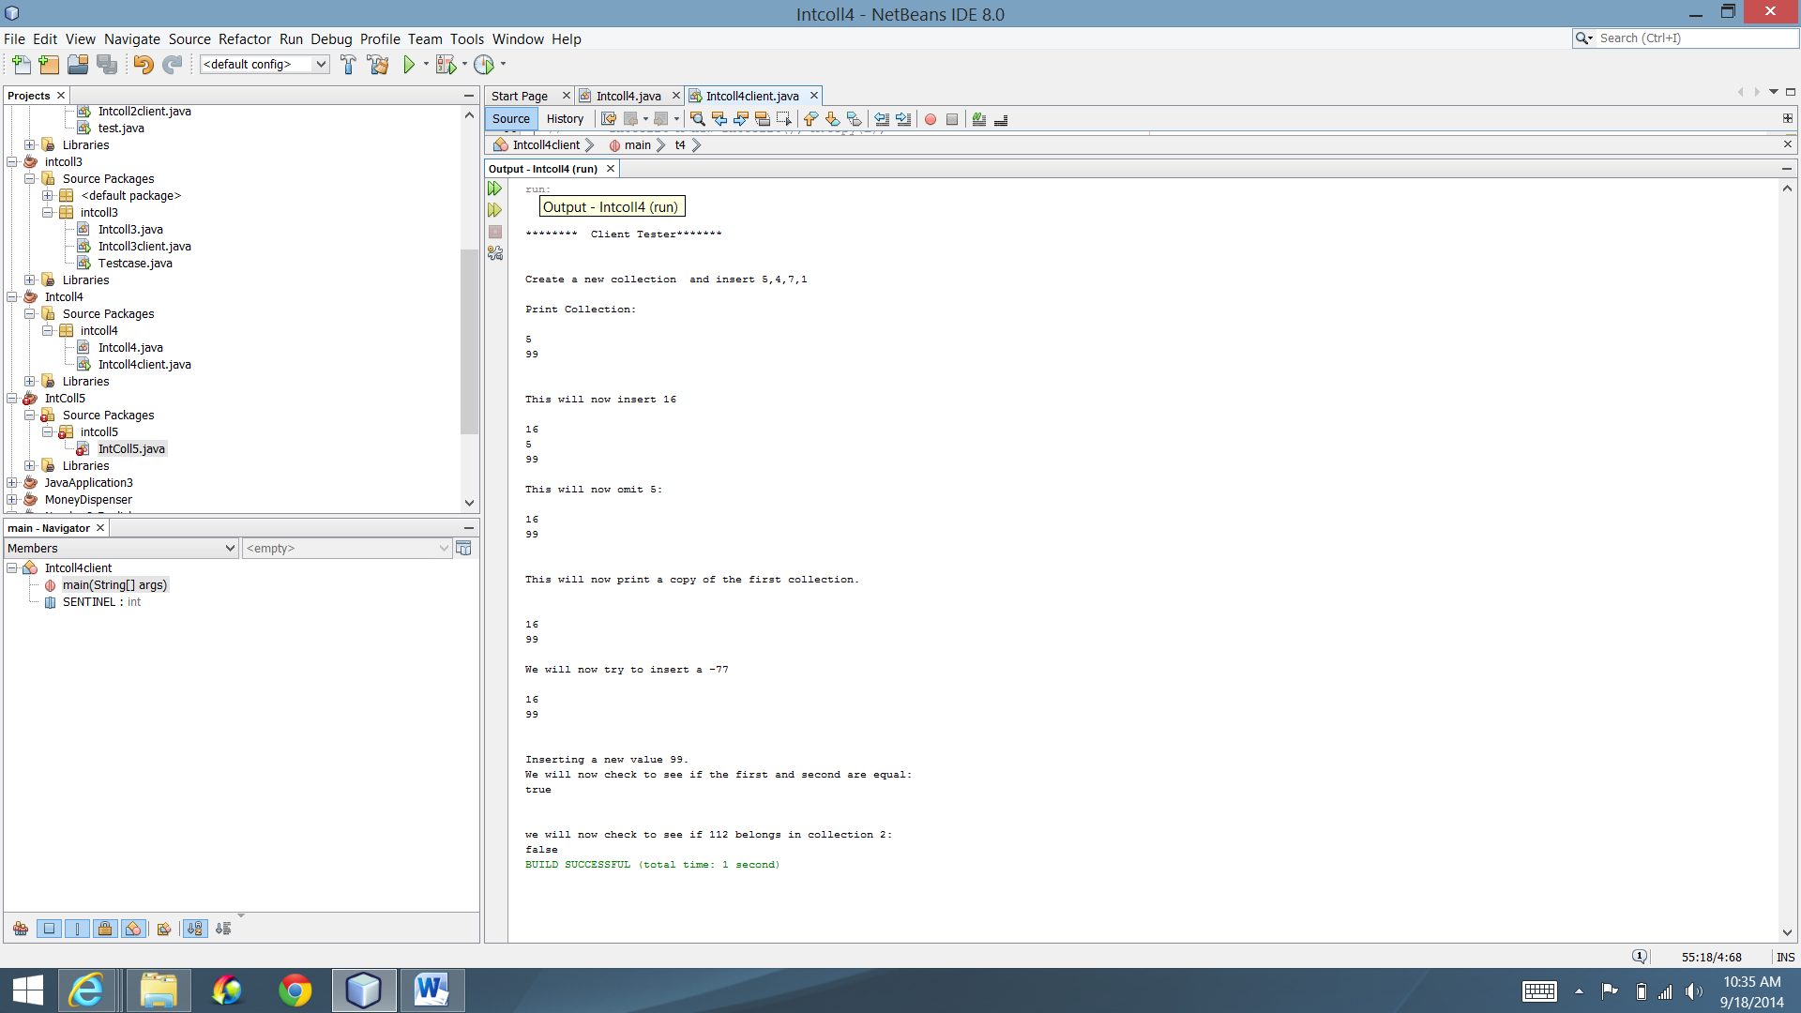

Test 4:

int t1 = -25;

int t2 =25;

int t3 = 5;

int t4 = 25;

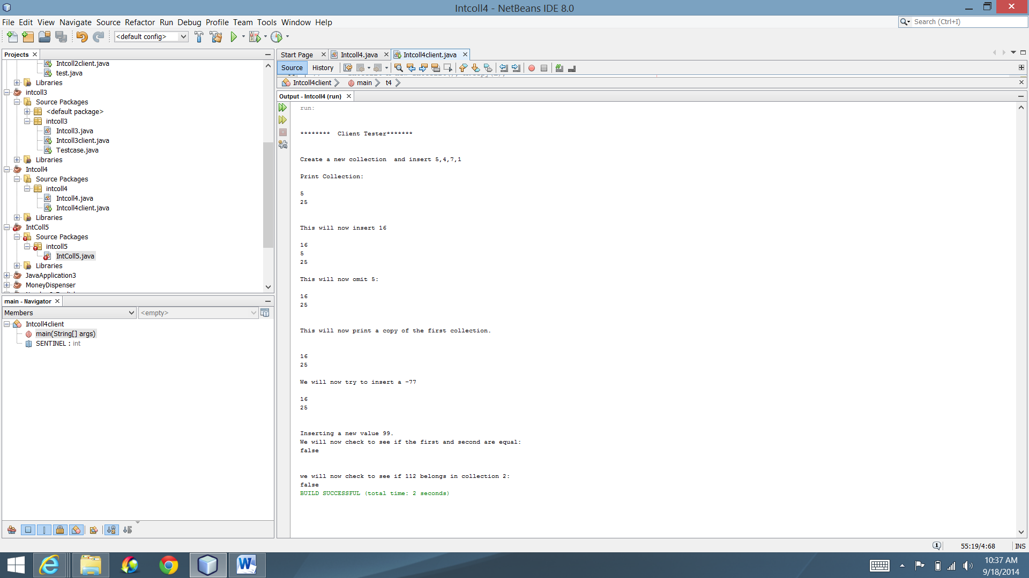

Test 5:

int t1 = -25;

int t2 = 88;

int t3 = 5;

int t4 = 909

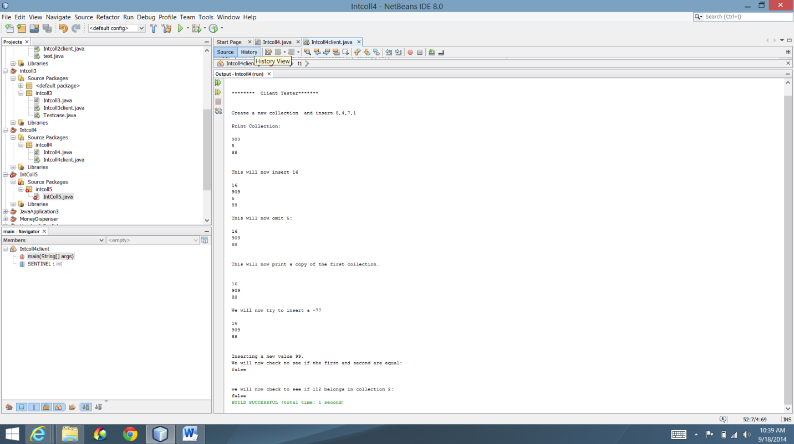

Original intcall4client output:

